**Spring Boot**

Spring Boot offers a new paradigm for developing spring applications with minimal friction. With Spring Boot, you’ll be able to develop spring applications with more agility and be able to focus on addressing your application’s functionality needs with minimal (or possibly no) thought of configuring spring itself.

**Main Goal of Spring Boot**

* To avoid XML Configuration completely
* To avoid defining more Annotation Configuration
* To provide some defaults to quick start new projects within no time

**Program 1: Sample Spring Boot Project**

**Step 1:** Createa maven project

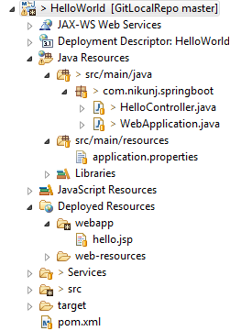

**Step 2**: Include spring boot dependencies in the pom.xml

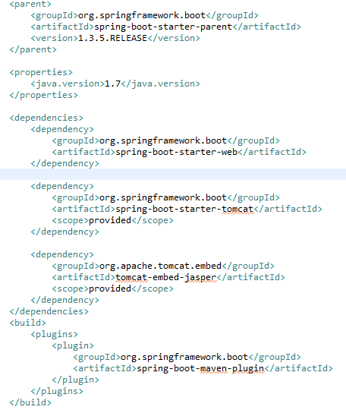

**Step 3**: Create spring boot app initializer

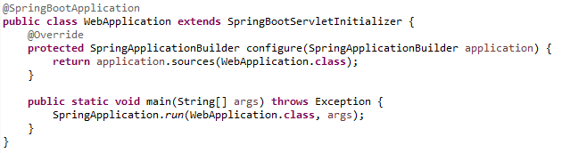

**Step 4**: Create a controller

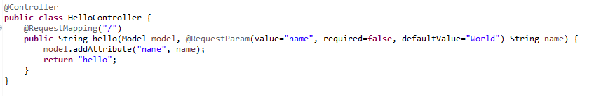

**Step 5**: application.properties (include prefix and suffix for view resolver)



**Step 6**: View Template

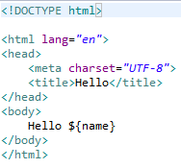

**Step 7**: I/P and O/P

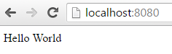

**Program 2: Spring Boot integration with MySQL and hibernate.**